July 25, 2008

Serb Leader’s Capture Brings Little Solace at Site of Killings in Bosnia
By DAN BILEFSKY
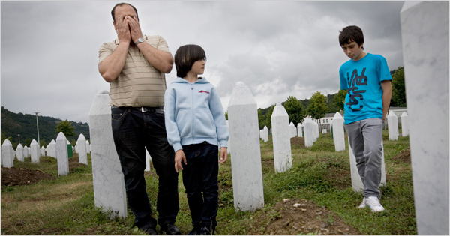
Johan Spanner for The New York Times
Sahbaz Mujcinovic and his sons visited the graves of his brother and father in Bosnia at a cemetery for Muslims killed by Serbian forces in Srebrenica in 1995.
SREBRENICA, Bosnia and Herzegovina — Fadila Efendik had little time to rejoice this week over the capture of Radovan Karadzic, the man she blames for the death of her only son: she was too busy looking for his missing and scattered body parts.
The arrest on Monday of Mr. Karadzic, the wartime leader of the Bosnian Serbs accused of masterminding the worst massacre since World War II, brought her cold comfort, Mrs. Efendik said.
She nervously played with her head scarf and sobbed as she scanned the endless rows of white gravestones here on Wednesday in the area where Serbian paramilitary forces under the command of Mr. Karadzic separated the men and boys who would later be killed in a frenzy that claimed 8,000 lives.
“I am bitter because it took so long to find Karadzic,” she said. “My son was two weeks shy of his 20th birthday. I still can’t find his body. I found some of my husband’s bones but not enough to bury him whole. Karadzic may have been found, but now I am alone in the world.”
When news of Mr. Karadzic’s arrest on war crimes charges broke on Monday, hundreds of Muslims poured onto the rainy streets of Sarajevo, the Bosnian capital. The city still bears the scars of a brutal three-and-a-half-year siege during which Mr. Karadzic is accused of authorizing the shooting of civilians.
Some danced and chanted, “This is Bosnia!” — a defiant answer to Mr. Karadzic’s wartime aim of the “ethnic cleansing” of Bosnian Muslims from the country and making it part of a greater Serbia. More than 10,000 Bosnians died in Sarajevo during the war.
But here in Srebrenica, where the massacre took place in 1995, locals said they had little faith in a legal process undertaken by the United Nations tribunal in The Hague 13 years after the hunt for Mr. Karadzic began. Some feared the tragedy he is accused of helping to orchestrate was being overshadowed by the lurid soap opera, played out on front pages across the world, detailing his evasion as an alternative medicine specialist, with a mistress, a fake American family and an elaborate disguise.
Mr. Karadzic has been indicted, along with the Bosnian Serb military commander, Gen. Ratko Mladic, on charges of genocide in connection with the killings during the siege at Sarajevo and the massacre at Srebrenica, where unarmed Bosnian Muslim men and boys were lined up, killed and buried in mass graves.
Mrs. Efendik said residual anger for the West’s inaction remained. In particular, she pointed to the 300 Dutch peacekeepers at the United Nations-protected enclave where 40,000 people had sought refuge before the killings. She said the peacekeepers should have done more to protect Bosnian Muslims from the raiding Serbian forces, some of whom stole the helmets and vehicles of peacekeepers to trick and capture victims trying to flee. Past Dutch governments have said responsibility for the massacre lay with the killers, not with the United Nations troops.
“The U.N. couldn’t save us then. What is it going to do now?” Mrs. Efendik said.
She recalled the day the killings began, when Serbian paramilitary forces separated the men from the women, putting the women on open trucks that would carry them to Muslim-controlled territory. She said the truck she was traveling on was stopped along the route, where the women were forced to watch and give the three-finger Serbian nationalist salute as Serbian forces mowed down their fathers, brothers and sons before their eyes.
Only a handful of the 8,000 men and boys survived, some by pretending to be dead and hiding under corpses. Witnesses said those who remained were herded to nearby wooded areas, soccer grounds, warehouses or barren meadows, where they were killed. Many bodies were later found in mass graves with their hands tied behind their backs.
Hatidza Mehmedovic, president of Srebrenica Mothers, a victims support group, who lost two young sons, her husband, her father and two brothers during the massacre, said she would be able to rest only when the West had brought Mr. Mladic to justice. For now, he remains at large.
“Karadzic gave the orders for Srebrenica, but it was Mladic who executed it,” she said. “I have some satisfaction from Karadzic’s arrest, but it doesn’t change the fact that Srebrenica remains a mirror to the shame of the world and its inaction. All those who could have prevented this should see the graves so that this will never happen again.”
Ms. Mehmedovic said all that she had left of her two sons, Almir and Azmir, 19 and 21 when they were killed, was a tree Almir had planted in her front yard and a school notebook Azmir had left on his desk. “We were awaiting the wedding of our children, the birth of our grandchildren,” she said. “Now all we have are empty graves.”
She said Mr. Karadzic’s arrest was little solace for thousands of families like hers that had not been able to bury their loved ones because forensic experts had recovered only part of their remains. Last year, she said, she found the mangled body of one of her sons, but was unable to identify which one. She also found the bones of her husband, but not enough to give him a proper burial.
Avdo Suljic, 35, an unemployed Bosnian Muslim who lost 200 relatives at Srebrenica, ranging in age from 16 to 85, said he had only recently returned, for fear of confronting too many ghosts. He recalled he had escaped being killed by trekking seven days in the mountains, drinking rainwater and hiding. “Karadzic is an old man. Nothing with his arrest has changed for me. I have no job and little future.”
Mr. Suljic, who fought with Bosnian forces during the war, said the war had devastated the town economically. He said he spent his days gambling and drinking. He noted two events that eased his pain since he returned to Srebrenica two years ago. “I found my father’s legs two years ago, and two weeks ago I found his head,” he said.
Copyright 2008 The New York Times Company

