July 10, 2009

China’s President Vows to ‘Deal a Blow’ to Protesters
By ANDREW JACOBS
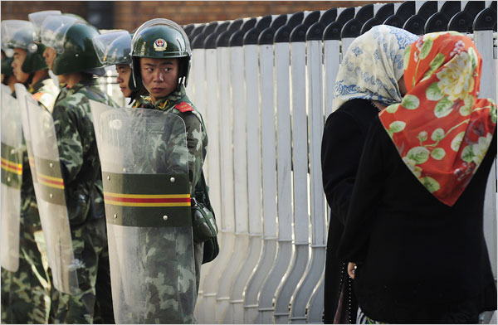
Peter Parks/Agence France-Presse — Getty Images
Chinese soldiers stood next to Uighur women at a security fence in Urumqi, which has settled into an uneasy calm.
BEIJING — In his first comments on the deadly riots in China’s far northwest, President Hu Jintao called Thursday for stability and promised harsh punishment for those found to have played a role in the disturbances that have killed scores of people and injured more than a thousand.
Mr. Hu, who cut short his appearance at the Group of 8 summit meeting in Italy, issued a statement along with the Communist Party’s top leadership that calls on the authorities to “isolate and deal a blow to the small group” who had a hand in the bloodshed, which killed at least 156 people during three days of unrest in Urumqi, the provincial capital of Xinjiang. They also suggested there would be leniency for those who had been “misled” by agitators.
“Preserving and maintaining the overall stability of Xinjiang is currently the most urgent task,” said Mr. Hu, according to a statement published by the New China News Agency.
On Wednesday, the party chief of Urumqi offered even tougher words. “To those who have committed crimes with cruel means, we will execute them,” said the official, Li Zhi.
Mr. Hu’s statement, jointly issued by the other eight members of the Politburo, came as Urumqi settled into a second day of uneasy calm. As many as 20,000 troops from nearby regions poured into the city, forming human cordons between Uighur neighborhoods and those dominated by Han Chinese, who had earlier gone on a revenge spree against Uighur residents.
Both Uighur and Han claim to be the predominant victims of the violence, but the government has declined to release a breakdown of the dead.
A nighttime curfew remained in Urumqi, but by 8 a.m. on Thursday shops were beginning to reopen for the first time as thousands of anxious residents clogged the city’s bus and train stations seeking to escape the city. As helicopters hovered overhead, military vans roamed the streets with loudspeakers blaring slogans like “Maintain stability” and “Protect the people.”
The turmoil began at a southern Chinese shoe factory last month after Chinese workers, spurred by false accusations of rape, attacked Uighur co-workers, killing at least two. The government’s failure to aggressively prosecute those involved in the brawl became a rallying cry for Uighur students in Urumqi, who organized the protest last Sunday that turned violent.
Uighurs, who are Turkic-speaking Muslims, form a minority in Urumqi, a city of 2.3 million that has been heavily settled by ethnic Han from other parts of China. The influx of so many outsiders, and what many describe as Beijing’s heavy-handed rule, have helped foment resentment among Uighurs.
Since the turmoil began on Sunday, China has accused Rebiya Kadeer, an exiled Uighur leader, of fomenting the strife. Ms. Kadeer, who lives in Washington D.C., has denied the charge.
But on Wednesday, the government for the first time shifted some of the blame to the United States, which it accused of financing Ms. Kadeer’s organization, the World Uygur Congress, and other groups that advocate human rights and democracy for ethnic Uighurs in China. The accusation appeared in an article in the Peoples Daily, the Communist Party’s official newspaper. In recent days Turkey, which has cultural and linguistic ties to China’s Uighurs, has stepped into the fray. On Thursday the minister for trade and industry called for a boycott of Chinese goods to protest the crackdown in Xinjiang. “If the country where we consume the goods does not respect human values, we should reconsider our values,” said the minister, Nihat Ergun, according to the Anatolia news agency.
Edward Wong contributed reporting from Urumqi, China.
Copyright 2009 The New York Times Company

