Bombs explode in two Greek cities
Al Jazeera
2 September 2009

Two bombs have exploded in separate attacks in Greece, one outside the Athens stock exchange and another outside a government building in the northern city of Thessaloniki.
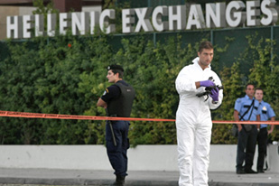
One of the bombs targeted the stock exchange building in the Greek capital [Reuters]

The attack in Athens, Greece's capital, exploded outside the city's stock exchange, causing serious damage to the building and nearby cars, and left one woman with minor injuries.
"The blast caused extensive damage, to the stock exchange building itself
and to nearby cars, five of which were completely destroyed," Panayiotis Stathis, a police spokesman said.
He added that the "methodology" of the blast pointed to the Revolutionary Struggle, a far-left group, although no one has yet claimed responsibility.
The second bomb, hidden in a cooking pot, exploded near a government building in Thessaloniki, causing some damage but no injuries.
Phone warnings to Greek media were made before both blasts, in what appears to be a series of attacks against financial insitutions and government buildings.
Violence in Greece has escalated since police shot dead an Athens teenager last December.
The shooting sparked Greece's worst riots in decades.
While bomb attacks against foreign and domestic banks and other targets have become more frequent in recent months, they are usually organised to avoid causing injury.

