Lorry bombers target Iraqi Kurds
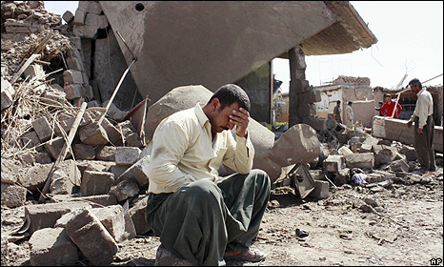
Houses on the village of Wardek collapsed with the force of the blast
September 10, 2009
A lorry packed with explosives has been detonated in a Kurdish village in northern Iraq, killing at least 19 people, Iraqi police say.
Around 30 other people, including women and children were injured in the blast in the village of Wardek, 50 km (30 miles) east of Mosul.
A number of homes were destroyed and police fear the death toll will rise as a search of the rubble is carried out.
A second lorry bomb in the village failed to detonate.
The driver was killed after local Kurdish Peshmerga militia opened fire on the lorry on the edge of Wardek, police said.
The blast went off around midnight (2100 GMT Wednesday).
It is the latest in a series of attacks on ethnically-mixed villages in northern Iraq.
A similar bombing in another village last month left 28 dead.
Mosul, Iraq's third biggest city, and the surrounding area has remained mired in violence despite the US military surge.
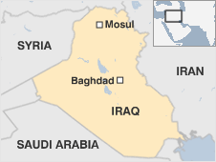
US and Iraqi officials say al-Qaida insurgents have regrouped in the city after being driven out of neighbouring Anbar province, and are believed to want to provoke ethnic tension and violence.
The city is also characterised by communal strife between Kurds and Arabs and violence targeting religious minorities.
In late 2008, the UN refugee agency reported that 13,000 Christians had been driven out of the city by violence and intimidation.
American, Iraqi and Kurdish officials are currently discussing plans to reinforce security in the region.
Story from BBC NEWS:
http://news.bbc.co.uk/go/pr/fr/-/2/hi/middle_east/8247651.stm
Published: 2009/09/10 09:22:48 GMT
© 2009 BBC MMIX

