**Militia chaos in Bani Walid raises danger of civil war in post-Gaddafi Libya**

**By Nick Meo, and Hassan Morajea, Bani Walid**

**The Telegraph**

**28 Jan 2012**

Libya has become used to uprisings - but this time it was “freedom fighters” who were forced out of the town of Bani Walid, a former Gaddafi stronghold, by a population they claimed to have liberated.

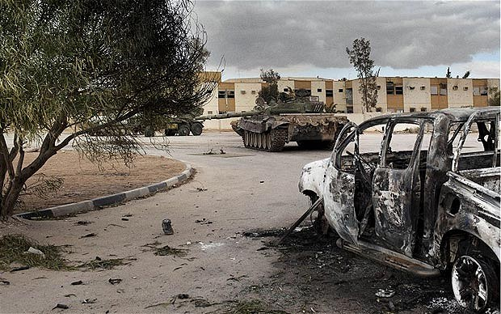

The compound where the clash happen Libyan National Guard Brigade 28 and local protesters happened in Bani Walid, Libya Photo: **DAVIDE MONTELEONE**

Mustafa Ben Hadia, a bearded young militia fighter, gripped his AK-47, scowled into the freezing desert wind, and spat out a curse on the men of Bani Walid, a few miles away over the scrubby hillside. In October when the war finished Mr Hadia expected to be back home in Tobruk within a few weeks, with a good civilian job as a reward for fighting to bring down Muammar Gaddafi. Instead he and a mob of thousands of armed young men in pick-up trucks were on Saturday preparing to restart the war and storm into Bani Walid, guns blazing, to grab fugitive Gaddafi officials and soldiers. "We know there are Gaddafi guys there, we found documents in the town," he said. "We have lists of them, they must be handed over." Another young fighter, wearing the new all-black uniform of the interior ministry, was equally gung-ho. "We're ready to attack, we're waiting for the order," he said.

Bani Walid, about 100 miles south-east of the capital Tripoli, was a Gaddafi stronghold, fighting defiantly to the bitter end under the direction of his son Saif al-Islam. The town only surrendered after dozens of its young men were killed by rocket barrages which smashed buildings to pieces.

Since its fall in October it has been a place of simmering resentment and occasional violent flare-ups. Then last Monday its tough inhabitants staged an uprising. They overran guards at the main prison, where growing numbers of their friends had been detained, and ejected pro-government forces from the town, killing at least four of them.

In the past year Libya has become used to uprisings, but this time it was the turn of the former rebels - who called themselves the May 28 Brigade and still consider themselves to be freedom fighters - to be put to flight.

Yet this was not the start of a pro-Gaddafi counter-revolution so much as an act of frustration at the high-handed behaviour of the former rebels, who still consider themselves to be freedom fighters.

The town's inhabitants were tired of the militia men barging into their homes, pushing their wives around and looting their possessions. Even worse were the arrests of suspected Gaddafi officials. Thousands of men have been dragged away across Libya in the past few months to prison and in many cases torture, in some cases for revenge just because they came from a town that was pro-Gaddafi during the war.

Torture has become a stain on the face of the new Libya. The United Nations and human rights groups accuse militias of doing what Gaddafi's torturers used to do, with whips, chains and plastic hoses. Médecins Sans Frontières withdrew doctors from detention centres in Misurata last week, complaining they were being asked to patch victims up between torture sessions.

Officials quickly tried to calm the Bani Walid situation, trying to assure the outside world that this was a local dispute, not the rekindling of the war, whatever the young hotheads said. The defence minister, Osama Jueili, bravely drove into the town on Wednesday to negotiate with different factions, emerging at nightfall to declare that everything was "calm and normal".

He told The Sunday Telegraph: "There were just some armed clashes and it quickly came to an end. We are now fully in control."

But there was little sign yesterday that this was true. Some 100 days after Muammar Gaddafi's brutal killing at the hands of rebels, Libya looks more and more as if it is under nobody's control.

Two days before the Bani Walid uprising, nearly 500 miles away to the east in Benghazi, President Mustafa Abdel Jallil was humiliated in another upset for government rule, one that was less bloody but just as damaging to the credibility of Libya's new rulers.

He was mobbed by huge crowds of angry protesters who stormed his office and burnt one of his cars. The mob weren't Gaddafi loyalists – they were his own supporters, furious with him for the mess Libya is in and angry at the lack of progress made so far by the National Transitional Council he heads.

His deputy Abdul Hafez Ghoga was roughed up by the angry crowd, and afterwards resigned complaining of an "atmosphere of hatred".

Afterwards Mr Jallil issued a stark warning that clashes between militias were leading to a "bottomless pit" and warned of the danger of civil war. "If there's no security there will be no law, no development and no elections," he said.

The NTC, set up in March as Gaddafi's tanks closed on Benghazi, did a good job of rallying support against the dictator. But it has been unable to function effectively as a government and the fact that many of its members are former Gaddafi-era officials has infuriated protesters in Benghazi, whose expectations for post-Gaddafi Libya were sky-high. Enduring constant power cuts, rising prices, and joblessness, they demand to know where the money is now the oil is flowing again – and they suspect corruption.

Yet Libya has not yet spiralled into Iraq-style chaos. There are no car bombs. The streets are mostly safe, although drug dealing is more open than it was and there is more violent crime than before.

And the NTC can point to successes. One million children are back at school having missed classes during nine months of war and revolution, and the curriculum has been cleansed of Gaddafi-worship.

The oil industry is pumping 1.3 million barrels of oil per day, although not all the cash frozen during the war by sanctions against the regime has been released. Elections planned for June are still a long way off, and in the meantime the power vacuum is worsening by the day.

In effect Libya is still being run by the militias thrown up by the war. An estimated 200,000 young men with no jobs lounge at checkpoints, or continue to scour the desert, armed and dangerous, hunting Gaddafi supporters or any black Africans who might have served as mercenaries in the Gaddafi army.

The NTC has proved unable to disarm more than a handful of the militia men, who show little interest in returning to the more humdrum jobs they held before the uprising.

The sheer profusion of militias adds to the problem: one estimate puts the number of military committees in Tripoli alone at 140. Last month they still occupied 31 schools which they had taken over as temporary barracks.

The events at Bani Walid were a stark example of how things can go badly wrong when a militia is involved. When the May 28 Brigade was ejected from the town last week, thousands of other former rebel fighters streamed to the town from across Libya, spoiling for a fight. Commanders loyal to the NTC have been occupied as much with restraining them as with persuading the town to surrender.

"When there are guns and the level of uncertainty is so high, it only needs one assassination or a car bomb to trigger a civil war," said Noman Benotman, a Libya analyst and former member of the Libyan Islamic Fighting Group. "And now there is a struggle for power going on." Like most Libyans he expects years of turmoil, if not civil war.

On the approach roads to Bani Walid, still lined with shot-up buildings and tanks destroyed in last autumn's fighting, there are plenty of armed young men who are ready for either.

Colonel Abdullah Mehdi, an NTC loyalist waiting outside the town for the order to attack, insisted his men were ready to take back control. He said: "We cannot allow grey zones, no-go zones, to exist in this country."

Additional reporting Richard Spencer, Cairo

*© Copyright of Telegraph Media Group Limited 2012*