'Scores dead' in Pakistan offensive
Al Jazeera
6 September 2009

At least 43 fighters have been killed by troops in Pakistan's northwestern Khyber region, government officials say.
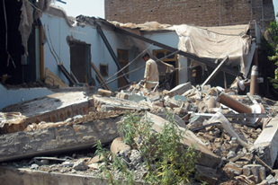
Government officials said the offensive would continue until all fighters are flushed out [AFP]

At least 15 fighters were killed on Saturday in the first clash, while 28 others were killed in air raids on suspected fighters' hideouts, the officials said on Saturday.
"Our forces targeted a headquarters of Lashkar-e-Islam and about 15 militants were killed in the attack," a Frontier Corps spokesman in Peshawar , the capital of NWFP, said.
Lashkar-e-Islam is under the command of Mangal Bagh, an ethnic Pashtun fighter.
The group is suspected to have links with al-Qaeda and has been a main target of the latest government offensive in Khyber, which authorities say has killed scores of suspected fighters.
The Khyber operation was launched about a week ago after a suicide bombing at a border checkpoint killed 19 police officers.
Tariq Hayat, a senior government official in Khyber, said the operation would continue until all fighters were flushed out of the region.
Intense pressure
Fighters frequently attack tankers along Khyber, a main route for supplies destined for US troops in Afghanistan.
Pakistan is under intense US pressure to crack down on fighters along the Afghan border, especially the lawless tribal belt where Osama bin Laden, the al-Qaeda leader, is believed to be hiding.
The US believes the fighters use Pakistan's tribal areas and other troubled parts of the northwest as safe havens from which to plan attacks on Western troops across the frontier.
Helicopter gunships and fighter jets also pounded fighters' positions in the tribal region of Orakzai that borders Khyber.
Intelligence officials said there had been casualties.
In Swat, meanwhile, security forces killed a fighters' commander and arrested five others, according to a military statement.
Seven more fighters surrendered to security forces.
The military said troops also destroyed two hideouts in the neighbouring Dir region.
Source: | Agencies

