Charles Taylor: profile of a warlord
By Mike Pflanz, The Telegraph
26 April 2012
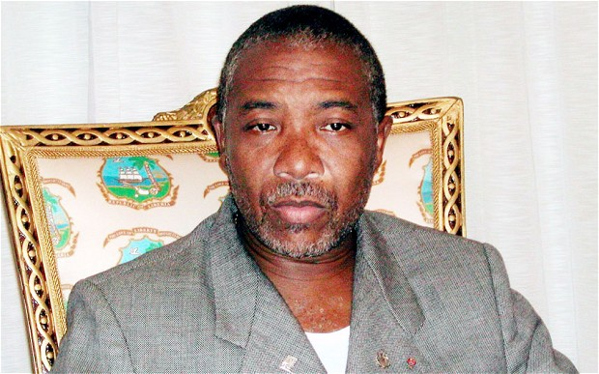
Credit: AP
The business of war profits many men, but those with the charisma, the arrogance and the force of personality of Mr Taylor profit the most

But the influence of this US-educated one-time Baptist lay preacher who rose to become one of West Africa's most feared despots reached deep into Sierra Leone's forested hinterland and down to its Atlantic Ocean beaches.
The bullets and the guns used by one of the country's most feared rebel groups, it is alleged, were all supplied by Mr Taylor's henchmen, in return for diamonds dug up from mines in rebel territory.
The business of war profits many men, but those with the charisma, the arrogance and the force of personality of Mr Taylor profit the most.
When accused during a BBC interview of being a "murderer", Mr Taylor compared himself to Jesus Christ, who, he said, "was accused of being a murderer in his time".
Born in Liberia to parents descended from freed American slaves, Charles McArthur Taylor studied economics in Massachusetts and then returned home to win a lucrative government job in charge of all state procurement.
He was sacked on suspicion of embezzling more than USD1 million, and fled to the US, where he was arrested but managed to escape jail.
He then disappeared, but is understood to have spent several years in Libya being trained in guerrilla warfare by Colonel Gaddafi's closest military advisers.
From there, his assault on his home country began. Starting with a coup on Christmas Eve 1989, which he announced to the world via a phone call to a BBC radio studio, he soon took control of Liberia.
His forces were bolstered by child soldiers, press-ganged into the Small Boys Unit and fed a diet of drugs to keep them at the front line.
As neighbouring Sierra Leone fell into deeper into civil war, Mr Taylor, now ruling most of Liberia with an iron grip, saw a chance to profit.
He would exchange guns for diamonds, which could then be sold on to finance his own campaigns, prosecutors in his trial claim. He denies all the charges.
He won the Liberian presidency after polls in 1997 during which his supporters adopted the unofficial slogan of "he killed my ma, he killed my pa, but I'll vote for him anyway".
He was only ejected from power when rivals took control of Monrovia, Liberia's capital, in 2003. He lived in exile as a guest of the Nigerian government for a further three years, before being arrested trying to flee into Cameroon in a Range Rover stuffed with stolen cash. He was handed over to the UN, and from there to the court's officers.
Copyright 2012 The Telegraph Media Group Ltd.

