South African Youth Leader Is Given a Mild Punishment After a Series of Gaffes
By Barry Bearak, The New York Times

11 May 2010

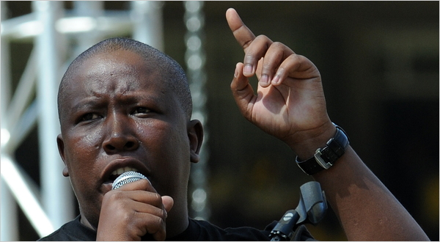
Alexander Joe/Agence France-Presse — Getty Images
Julius Malema, president of the youth league of the African National Congress, addressing a rally in Johannesburg in 2009.
JOHANNESBURG — Julius Malema, the inflammatory president of the governing party’s youth league, was given a mild punishment by party elders on Tuesday after a disciplinary hearing that many here once expected to yield a far harsher comeuppance.
Mr. Malema was permitted a plea bargain, resulting in the withdrawal of three internal charges against him in exchange for a guilty plea in one other. His censure includes a public apology, mandatory education in anger management and leadership skills, and a fine of about $1,300.
The announcement by a disciplinary committee of the party, theAfrican National Congress, included Mr. Malema’s agreed-upon portion of humble pie, with his admitting that his “public utterances should at all times reflect respect and restraint.” He promised to learn from his mistakes.
Last month, when President Jacob Zuma publicly reprimanded his best-known disciple, there was speculation that Mr. Malema might well face expulsion from the party and the possible dead end of a political career.
But the 29-year-old leader of the youth league has a huge following and has proved an able field general in getting out the vote. While he has offended many in the A.N.C.’s hierarchy, he also has important allies.
The three charges that were dismissed had seemed the most serious. In early April, Mr. Malema made a trip to Zimbabwe, where he allied himself with the 86-year-old autocratic president, Robert Mugabe. This exchange of affections came while Mr. Zuma was involved in delicate negotiations to solve that country’s political crisis. A show of impartiality was considered essential for success.
Mr. Malema also resurrected a liberation-era song that included the words “shoot the Boer,” a lyric that, if taken literally, calls for the killing of Afrikaners. A judge banned the singing of the song — and the party itself issued instructions to stop the racially divisive renditions. But the youth league leader defiantly continued to lead crowds in the forbidden singalong.
A third charge involved the rude treatment of a BBC correspondent, Jonah Fisher, whom Mr. Malema maligned and threw out of a news conference.
The charge that Mr. Malema did not escape involved an implied criticism of Mr. Zuma, comparing him unfavorably with former President Thabo Mbeki at a provincial youth congress on April 11.
“Comrade Julius Malema shall make a public apology to the president of the A.N.C., the A.N.C. and the public in general,” read the disciplinary committee’s statement.
It further threatened Mr. Malema with suspension from the A.N.C. if he is again found guilty of provoking party divisions within the next two years.

A version of this article appeared in print on May 12, 2010, on page A9 of the New York edition.

Copyright 2010 New York Times Company.

