South Sudan: Cattle raid in Warrap state 'kills 40'
BBC NEWS
30 January 2012

At least 40 people have been killed by armed gunmen in a cattle raid in South Sudan, officials say.
Some reports say as many as 100 people could have been killed in the attack on a camp in Warrap state.
South Sudan's interior minister accused the Sudanese government in Khartoum of arming the attackers, a militia group from neighbouring Unity State. Tensions remain high since South Sudan seceded peacefully from Sudan in July after decades of war. Cattle play a vital role in the lives of many South Sudanese communities. Hundreds of people have been killed in a series of tit-for-tat cattle raids in Jonglei state in recent weeks. An official in Warrap state told the Paris-based Sudan Tribune newspaper that villages belonging to the Luac Jang ethnic group in Tong East county came under attack early on Saturday. Madot Dut Deng, speaker of the state assembly, said he had been told by officials that more than 76 people had been killed, with several unaccounted for. Another state official told the newspaper that local people spoke of as many as 100 people killed. Local MP Mayiik Ayii told the BBC he had been told many children were among the dead. Interior Minister Alison Manani Magaya said the attack was carried out by a militia group from neighbouring Unity state, the AFP news agency reports. "This militia group was armed by the government of Khartoum," he said, but could not name the specific group responsible. "The number of wounded is still not clear, but they took a lot of cattle with them," he added. Sudan has denied similar accusations in the past. Mr Ayii said that the area which was attacked had been disarmed, leaving it vulnerable to attack by rival groups.

'Critical point'
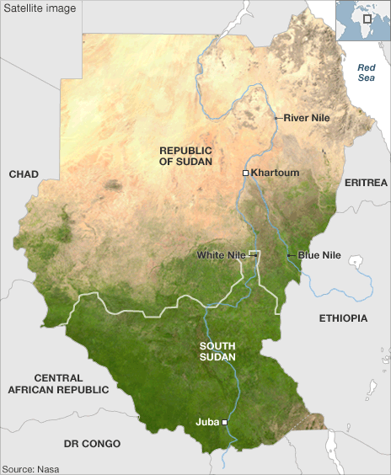
South Sudan became independent on 9 July 2011 following decades of civil war with the north. One legacy of the conflict is that the region is still flooded with weapons; another is the lack of roads, making it difficult for the security forces to intervene. UN Secretary General Ban Ki-moon on Sunday urged the leaders of Sudan and South Sudan to reach agreement on how to divide up their oil wealth, a key source of tension between the two. "The situation in Sudan and South Sudan has reached a critical point. It has become a major threat to peace and security across the region," Mr Ban said in a speech to an African Union summit in the Ethiopian capital Addis Ababa. South Sudan has stopped pumping oil after Sudan confiscated shipments, saying it had not been paid for transit fees. Sudan lost most of its oil when the south became independent but the pipelines run through Sudan to Port Sudan on the Red Sea.

Sudan: A country divide
The great divide across Sudan is visible even from space, as this Nasa satellite image.The northern states are a blanket of desert, broken only by the fertile Nile corridor. South Sudan is covered by green swathes of grassland, swamps and tropical forest. Sudan's arid north is mainly home to Arabic-speaking Muslims. But in South Sudan there is no dominant culture. The Dinkas and the Nuers are the largest of more than 200 ethnic groups, each with its own languages and traditional beliefs, alongside Christianity and Islam. The health inequalities in Sudan are illustrated by infant mortality rates. In South Sudan, one in 10 children die before their first birthday. Whereas in the more developed northern states, such as Gezira and White Nile, half of those children would be expected to survive. The gulf in water resources between north and south is stark. In Khartoum, River Nile, and Gezira states, two-thirds of people have access to piped drinking water and pit latrines. In the south, boreholes and unprotected wells are the main drinking sources. More than 80% of southerners have no toilet facilities whatsoever. Throughout Sudan, access to primary school education is strongly linked to household earnings. In the poorest parts of the south, less than 1% of children finish primary school. Whereas in the wealthier north, up to 50% of children complete primary level education. Conflict and poverty are the main causes of food insecurity in Sudan. The residents of war-affected Darfur and South Sudan are still greatly dependent on food aid. Far more than in northern states, which tend to be wealthier, more urbanised and less reliant on agriculture. Sudan exports billions of dollars of oil per year. Southern states produce more than 80% of it, but receive only 50% of the revenue. The pipelines run north but the two sides have still not agreed how to share the oil wealth in the future.

BBC © 2012

