In South Sudan, tribal violence adds to fledgling nation's woes
By Robyn Dixon, Los Angeles Times
14 March 2012
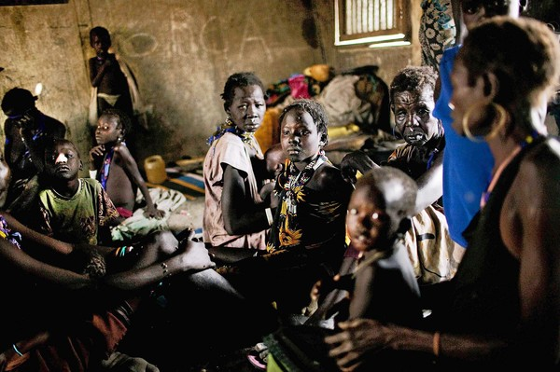
Displaced Murle women take shelter at a school in Pibor, South Sudan. More than 200 people were killed last week in the latest outbreak of violence between the Nuer and Murle tribes. (Pete Muller / Associated Press / February 2, 2012)
Reporting from Juba, South Sudan— The two wards are at opposite ends of the hospital. One ward is silent but for a baby boy, gurgling on a bed in a corridor. A toddler wanders around with a machete scar on his head. The boys' parents are dead.

In the other ward lies one of the men who attacked them. When Gai Nashir was a baby, his father was also killed, by members of the boys' tribe. Quick to anger, he grew up with an enemy.

"This war began before I was even born," says Nashir, who was wounded in December when he and other members of his Nuer tribe shot and hacked to death hundreds of men, women and children of the Murle tribe in the darkest episode in the short, troubled history of the world's newest country, South Sudan.

The ongoing tribal violence, which saw more than 200 people killed last week in the latest outbreak, poses a serious threat to a fragile state still recovering from a long war for independence from the Sudanese government. With memories of the bloodshed in Sudan's Darfur region fresh, the displacement of 125,000 by the fighting in Jonglei state also raises the risk of yet another humanitarian disaster in a region ill-equipped to handle one.

The tribal tension is just one of the cascading problems that confront South Sudan, including a near-total lack of infrastructure and a war on its disputed border with Sudan that has caused 80,000 people to flee into South Sudan. There is mounting tension with Sudan over oil, most of which went to South Sudan with its independence; talks on the issue reportedly degenerated into a shouting match recently.

The December attacks exposed the government's failure to protect its citizens, and to offer services and jobs in a destitute region. Bitter young men whose tribes measure their wealth in cows are left reliant on cattle rustling and killing for their livelihood and marriage prospects.

"They're going to have to face up to national reconciliation," says a Western observer in Juba, the capital of South Sudan. "The issues for the Nuer and the Murle are basically the same. They feel completely abandoned by the government.

"They were saying: 'You have to come and help us. We need security, we need a buffer zone [between the tribal areas].' … The government's done nothing."

Bad blood between the Nuer and Murle tribes goes back generations, but a new wave of tribal killings exploded in Jonglei about a month after South Sudan's rapturous independence celebrations in July.

More than 1,000 have been killed since, according to the United Nations, although there is no definitive casualty figure in the vast, isolated region nearly the size of Iowa, with few roads or facilities such as schools and clinics.

The tribal violence has also seen the reemergence of an 8,000-strong Nuer militia called the White Army.

This week, South Sudan's government launched a new effort to disarm the White Army and Murle militias, by force if necessary, deploying 12,000 soldiers to carry out the campaign. A statement released by the White Army this month warned of a coup if the government tried to challenge it, vowing that any soldier who "will come to fight us will not go back alive."

Repeated peace efforts and disarmament of both sides in recent years have failed. Terrified of hated neighbors, with no government protection, people rearm themselves in a country awash withweapons.

The Murle minority of about 148,000 is often casually derided by other South Sudanese as "the problem" because of the tribe's history of trying to boost its numbers by abducting children of rival tribes.

But U.S. anthropologist Jon Arensen, who spent eight years living with the Murle in the 1970s and 1980s, says its members are often demonized in South Sudan.

"The Murle tribe is being portrayed as the aggressor," he wrote recently. "The Nuer tribe is being portrayed as noble warriors simply reacting to the attacks of the evil Murle people. Nothing is farther from the truth. Almost all the publicity being generated — both local and abroad — takes the position of the Nuer fighters."

The two sides fight differently: Murle men move like guerrillas in small bands, attacking, stealing cattle, abducting children and retreating. The Nuer move in huge, heavily armed columns of many thousands, pouring into enemy villages with devastating power.

Nuer militants presaged the December attacks on Pibor and surrounding villages with a statement announcing plans for genocide: "We have decided to invade Murleland and wipe out the entire Murle tribe on the face of the Earth."

Nashir, 35, married with five children, recounts the attacks on the Murle with grim pride. It was revenge, he says, for an earlier Murle attack on the Nuer town of Pieri. Six hundred were killed in that August attack, and up to 200 abducted, according to the U.N.

Copyright © 2012, Los Angeles Times

