South Sudan militia weapons came from army, rebels
By Ahram online news
23 March 2012
Reports reveal that so-called White Army militia which massacred a rival group earlier this year received direct support from Southern Sudanese army
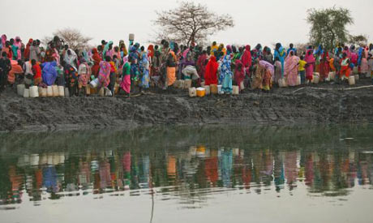
Displaced women gather to collect water from a water hole near Jamam refugee camp in South Sudan's Upper Nile State March 10, 2012. (Photo: Reuters)

Guns and ammunition used by a South Sudanese ethnic militia that massacred a rival group earlier this year came from both the army and a rebel group, a report said Thursday.
Beginning late December a marauding column of some 8,000 armed youths from the Lou Nuer people marched on the remote town of Pibor, home to the rival Murle, whom they blame for cattle raiding and have vowed to exterminate.

Analysis by the Small Arms Survey, a Swiss-based research group, suggests that the rampaging fighters were armed by a local rebel leader called George Athor -- killed in December -- as well as elements in the South Sudanese army.
"What is clear is that the inter-communal attack demonstrated an unprecedented level of organisation and scale of violence in South Sudan," the report said.
Analysis of bullet casings left after the attacks, as well as photographs of men with Kalashnikov automatic rifles and rocket-propelled grenades, "seems to confirm previous allegations that Athor had armed thousands of Nuer youth in Jonglei state," the report read.

Reports at the time suggested the militia force -- who called themselves the White Army -- received tacit, if not direct, support from the Southern army, who failed to stop the advancing column, claims the military has dismissed.Chinese-manufactured Kalashnikov bullets found close to massacre sites are the same as those used by the military, the Sudan Peoples Liberation Army (SPLA), the report added.

"This variety of ammunition is held in vast quantities by the SPLA, supporting allegations that Nuer members of the SPLA supported the White Army's attack on Pibor," the report added.
Eyewitness testimonies gathered by the aid agency Doctors Without Borders (MSF - Medecins Sans Frontieres) include reports of babies beaten against trees and women forced to watch their children have their throats slit.

Scores of people were treated for machete and gunshot wounds at clinics, and over 140,000 people were affected by the attacks and reprisal raids.
Grossly impoverished South Sudan, the world's newest nation which declared independence last July, is reeling from a wave of bloody ethnic violence and rebel attacks.

South Sudan had accused Athor of being armed by and acting on behalf of Sudan in a bid to destabilise the country, which won independence in July, five years after the end of a two-decade civil war with Khartoum, claims Athor denied.After the attack, Pibor Commissioner Joshua Konyi said he believed some 3,000 people had been killed, based on reports from community elders of those missing.
United Nations peacekeepers dispute those figures -- estimating deaths to be likely in the hundreds, not thousands -- but are unable to say how many civilians they failed to protect.

© 2010 Ahram Online

