Swedish Parliament Recognizes Genocide
Asbarez News
11 March 2010

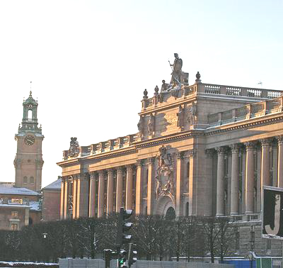
Sweden's parliament building
STOCKHOLM—The Parliament of Sweden on Thursday, recognized the Armenian Genocide after a long debate with a vote of 131 to 130.
The resolution mandates Sweden to officially describe the large-scale murders of Armenians and other ethnic groups in Turkey in the early years of the last century as genocide.
The motion was supported by members of five of the seven Swedish parliamentary parties including the Left Party, whose foreign policy spokesperson Hans Linde told The Local newspaper on Thursday that the time had come for Sweden to take a stand on the issue.
“First, to learn from history and stop it from repeating and second, to encourage the development of democracy in Turkey, which includes dealing with its own history. The third reason is to redress the wrongs committed against the victims and their relatives,” added Linde.
The committee in its comments on the motion argued for an open debate on the issue. It also stated that the persecution of the Armenians and other ethnic groups in 1915 would have constituted genocide according to the definition adopted by the United Nations in its 1948 genocide convention if it “had it been in force at the time.”
The Swedish parliament voted on the issue before, even approving a report in 2000 recognizing the disappearance of as many as 2.5 million Armenians, Chaldeans, Syrians, Assyrians and Pontian Greeks beginning on April 1915 as genocide. But the recognition was later withdrawn “on a technicality,” explained Linde.
Asbarez will provide more in-depth coverage of this issue.

