‘It is my Decision’ to Disrespect Genocide Victims, Says Turkey’s Cavusoglu
By Asbarez Post
13 May 2010
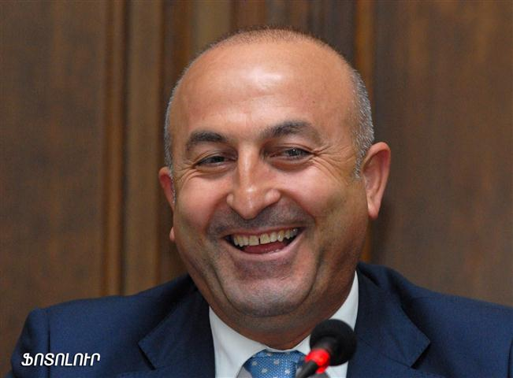
YEREVAN (Combined Sources)—Visiting president of the Parliamentary Assembly of the Council of Europe, Mevlut Cavusoglu told reporters Thursday that it was his own decision to not visit Dzidzernagapert and, as a result, disrespect the 1.5 million victims of the Armenian Genocide.

“The PACE rules do not contain a provision obligating each PACE President to follow a host country’s protocols,” said Cavusoglu, claiming that in the past two other PACE presidents had not visited Dzidzernagapert.

“Despite all this, it is my own decision. I respect your opinions, but everybody has to respect my decision,” urged the PACE president, who is a member of the Turkish parliament and a founding member of the Turkish ruling party.

Upon learning of his intentions to not visit Dzidzernagapert, Armenian authorities caved in and altered the format of the visit from an “official” to a “working” one. This prompted a decision by the Armenian Revolutionary Federation to boycott all meetings with Cavusoglu.

Other parties who claimed they would meet with Cavusoglu to personally address their dissatisfactions were all rebuffed by the PACE president.

Speaking about his nationality, the PACE President said that first of all he is the leader of the Assembly, who should fulfill his obligations regardless of anything. Cavusoglu had been head of the Turkish delegation prior to his election to the post of PACE President.

During the press conference, Cavusoglu also reported that in response to a letter from Nagorno-Karabakh Republic Parliament speaker, Ashot Ghoulyan, asking for official PACE observers to the upcoming parliamentary elections, the PACE presidency decided to not send an observer mission since PACE “does not send delegations to zones of frozen conflicts.”

Cavusoglu claimed that efforts to revive the subcommittee on Nagorno-Karabakh were already under way before he was elected president of the body.

Concerns have been voiced that the sub-commission cannot be impartial because Turkey continues to unconditionally support Azerbaijan in the conflict and Cavusoglu has made pro-Azeri statements that could taint the process.

“All the member countries of the Assembly have to abide by the Assembly resolutions,” Cavusoglu said. “But we are also pragmatic. Especially when there are different opinions on an issue.” He added that he will take the Armenian concerns into account even if he does not agree with them.

Copyright 2010 Azbarez Post.

