Hugo Chávez accuses Israel of genocide
Israelis 'openly exterminated' Palestinians in Gaza offensive, says Venezuelan president
- Rory McCarthy, Jerusalem
- guardian.co.uk, Wednesday 9 September 2009 12.33 BST
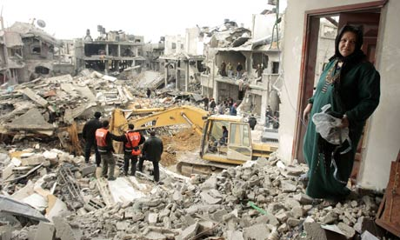
A Palestinian woman surveys her destroyed house after an Israeli air strike in northern Gaza in January. Photograph: Mohammed Salem/Reuters
Hugo Chávez, the Venezuelan president, has accused Israel of genocide against the Palestinians, saying the offensive in Gaza early this year was unprovoked.
"The question is not whether the Israelis want to exterminate the Palestinians. They're doing it openly," he was quoted as saying in an interview with the French newspaper, Le Figaro.
"What was it, if not genocide? ... The Israelis were looking for an excuse to exterminate the Palestinians." His comments came after a tour of Middle Eastern and Arab countries.
Israel has maintained that the three-week Gaza assault was a response to rockets fired from Gaza by militant groups. However, several human rights groups have said that both Israel and Palestinian militant groups, notably Hamas, breached international law and should be investigated for possible war crimes.
A key UN report on the conflict, led by the respected South African judge Richard Goldstone, is due to be published within weeks.
New casualty figures for the Gaza offensive, compiled after months of research by an Israeli human rights group, show 1,387 Palestinians died, of whom more than half were not taking part in hostilities. The research from B'Tselem, the Israeli human rights organisation, challenges figures produced by the Israeli military, which argued that far fewer Palestinian civilians died.
B'Tselem said that its field researchers in Gaza interviewed witnesses and relatives of the dead, cross-checked information with Palestinian and international rights groups and with Israeli military statements. "B'Tselem did everything within its capability to verify the data," the group said. It had asked to see an Israeli military list of fatalities but was refused. Israeli authorities also refused to allow Israeli and West Bank staff from B'Tselem to enter Gaza for the work.
The research found that 773 of those Palestinians killed were not taking part in hostilities; among them were 320 children under the age of 18. Field workers from the group visited the homes of the dead children, checking photographs, death certificates and other documents to establish the toll.
Another 330 of the dead were involved in the fighting and 248 were police officers killed at their police stations, most in a wave of air strikes on the first day of the conflict.
On the Israeli side, three civilians were killed by Palestinian militant rocket fire and 10 soldiers died, four of whom were killed accidentally by their own troops.
The Israeli military has released its own casualty figures for Palestinian deaths, saying 295 civilians were killed out of a total of 1,166 deaths, but has refused to publish its list of fatalities. The military said it believed that the B'Tselem report was "not based on facts or on accurate statistics".
Although the military defended its conduct in the war, it has emerged that officers have started taking witness testimony from some Palestinians whose relatives were killed and injured. On Monday, Israeli military officers questioned Khaled Abed Rabbo, who saw two of his daughters shot dead by Israeli troops during the war. A third daughter was severely injured. The troops then demolished the family's house, in Izbet Abed Rabbo, one of the worst damaged villages in Gaza.
© Guardian News and Media Limited 2009

