June 29, 2008
News Analysis

After Brutality, Mugabe Offers an Olive Branch
By CELIA W. DUGGER
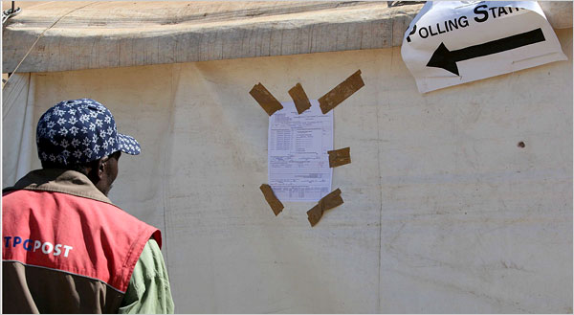
European Pressphoto Agency
The results of Zimbabwe’s runoff election, widely seen as a sham, were posted at a polling station in Harare. After a campaign of violence, the opposition party had withdrawn from the election.
JOHANNESBURG — President Robert Mugabe once boasted he had a degree in violence, and he has surely added a doctorate in the savage presidential runoff season that is likely to stagger to a close this weekend with his proclaiming himself the Zimbabwean people’s choice despite an election denounced across the globe as a sham.
In the three months since the opposition leader Morgan Tsvangirai beat him in the general election, Mr. Mugabe, 84, has accomplished much of what governing party insiders say he and his coterie of strongmen set out to do in the long delay they engineered before the runoff on Friday.
Soldiers, war veterans and unemployed youths mobilized by Mr. Mugabe’s ruling clique have decimated the ranks of the opposition, with the damage measured in shattered bones, battered and burned bodies and the corpses of assassinated organizers — a record that helped prompt President Bush on Saturday to announce that the United States would move forward with broader sanctions on the Zimbabwean government.
“Violence has left our structures scattered, tattered and seriously perforated,” acknowledged Nelson Chamisa, a member of Parliament and the spokesman for the opposition Movement for Democratic Change.
Now that he will have officially won a runoff that Mr. Tsvangirai quit with only days to go because of the extreme violence, Mr. Mugabe, in power for 28 years, is ready for talks with the opposition. “We want our brothers in the M.D.C. to come to us to discuss our problems,” he said at a rally on Thursday, exhibiting magnanimity that had earlier escaped him.
In that spirit, the opposition’s chief strategist, Tendai Biti, held for two weeks in one of the country’s filthiest jails on flimsy treason charges, was released last week. And doctors treating victims of Mr. Mugabe’s onslaught say torture camps in the Mashonaland provinces, the heartland of the gory campaign of terror, have been closed and the wounded are now straggling into Harare, the capital, for treatment.
The current moment has a familiar quality that has left some Zimbabweans wondering if Mr. Mugabe is up to old tricks.
In 1987, after conducting a murderous campaign to crush the forces of a rival liberation hero, Joshua Nkomo, Mr. Mugabe and Mr. Nkomo signed a unity accord that merged the two forces into a single party, ZANU-PF, that still rules Zimbabwe.
The historian Martin Meredith explains in his book “The Fate of Africa” that Mr. Mugabe’s objective was always to establish a one-party state. The question now is whether he can again succeed in bludgeoning an independent force into submission.
There is one major, imponderable difference now: the gruesome violence has been inflicted in the Internet age. The photographic and video evidence of atrocities is online in real time: the women whose bottoms were beaten for so many hours they have turned deep purple, the men whose backs are pocked with burns from dribbled, burning plastic, the boys and girls with broken legs and black eyes.
These images, more than anything else, have created a worldwide revulsion to Mr. Mugabe and an avalanche of denunciations from Western leaders and some African heads of state on a continent where many have been silent during Mr. Mugabe’s pitiless decades in power.
But Mr. Mugabe is a cunning survivor. The chief mediator between him and Mr. Tsvangirai is South Africa’s president, Thabo Mbeki, who has a complicated relationship with Mr. Mugabe that stretches from 1980. Mr. Mbeki has uttered nary a word directly criticizing Mr. Mugabe in the past three months and is now pushing hard for Mr. Mugabe and Mr. Tsvangirai to talk. Some senior members of Mr. Mbeki’s own party have said in recent interviews that they think Mr. Mugabe has for years outfoxed South Africa’s president.
Still, Mr. Mbeki is sticking with the policy of quiet diplomacy he has pursued with Mr. Mugabe for the past several years. South Africa has fought to keep Zimbabwe off the international agenda, and on Friday it opposed an effort led by the United States and Britain to have the United Nations Security Council pronounce the runoff illegitimate, saying it was not the Council’s role to do so. Instead, the Security Council issued a weaker statement regretting that the runoff was not postponed.
South Africa also opposes sanctions against Zimbabwe.
President Bush said Saturday that the United States would press the United Nations for an arms embargo on Zimbabwe and a travel ban on government officials. He also said he was instructing American officials to develop sanctions against Zimbabwe’s government. Currently, the United States sanctions apply only to some 140 members of Zimbabwe’s elite and businesses they own or control.
Ronnie Mamoepa, spokesman for South Africa’s Foreign Ministry, explained that while South Africa’s own liberation movement sought international sanctions against the apartheid regime, Zimbabwe’s opposition has not asked for them.
Mr. Mamoepa said it did not make sense to impose sanctions now when both sides were already willing to enter negotiations for a political settlement.
He also said South Africa had not yet expressed any view on the validity of the election.
“Our principal task is to bring the two belligerents to the table to talk about the future of the country,” he said.
South Africa’s studied neutrality has embittered many in the opposition.
“If Mbeki endorses and legitimizes Robert Mugabe and ZANU-PF,” said Mr. Chamisa, “instead of being part of the solution, he risks being part of the problem.”
Copyright 2008 The New York Times Company

