Zimbabwe Convicts 6 Who Viewed Revolt News
By Lydia Polgreen, The New York Times
19 March 2012
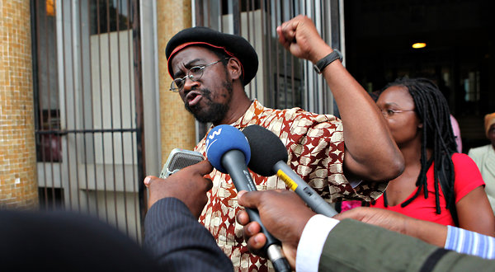
Tsvangirayi Mukwazhi/Associated Press
Munyaradzi Gwisai, a political activist and former member of Parliament for Zimbabwe’s main opposition party, left court in Harare on Monday after being convicted of plotting to overthrow the government.
JOHANNESBURG — Six political activists in Zimbabwe who gathered last year to watch and discuss television news broadcasts of the Arab Spring protests were convicted on Monday of conspiring to commit violence in an effort to overthrow the government.
The penalty could be 10 years in prison. They are to be sentenced on Tuesday.
About 45 activists, students and trade unionists were arrested last February while attending a meeting convened by Munyaradzi Gwisai, a lecturer at the law school at the University of Zimbabwe and a former member of Parliament for Zimbabwe’s main opposition party, to discuss the antiauthoritarian uprisings in Egypt and Tunisia.
Prosecutors claimed that Mr. Gwisai and the others were planning to start a similar uprising in Zimbabwe aimed at toppling President Robert G. Mugabe, who has been in power for three decades. Most of the defendants were later released, but six, including Mr. Gwisai, were charged with serious crimes. Lawyers for the accused said the meeting was an academic discussion, not a planning session for a revolution.
The judge in the case, Kudakwashe Jarabini, said in court that while watching videos of the Arab uprisings was not a crime, the organizers had intended to incite hostility toward the government by playing them, according to people in the courtroom.
Mr. Mugabe’s ZANU-PF party has been in a tenuous unity government with the main opposition party, the Movement for Democratic Change, led by Morgan Tsvangirai, since the 2008 election. Mr. Tsvangirai won the most votes but dropped out of the race because of violence against his supporters. International pressure led to the creation of a unity government. But Mr. Mugabe retained the most crucial government posts, particularly those that control the police and the army.
Mr. Mugabe’s party has been pushing hard for new elections, hoping to retake power while Mr. Mugabe, 88, whose health has grown more fragile, remains alive. But the Movement for Democratic Change and many activists and analysts have argued against holding elections before a new constitution is drawn up and crucial institutions, like the election commission, are reformed. An estimated 350 people died in violence during the 2008 election.
Shortly after the 45 activists were arrested last year, a lawyer working for them reported that a dozen had been tortured to try to force them to testify for the state and that six had been lashed. The accusations prompted a letter of concern from the United Nations torture investigator, Juan E. Méndez.
Dewa Mavhinga of the Crisis in Zimbabwe Coalition, a collection of hundreds of civic groups, said it appeared that the window for change in Zimbabwe was closing.
“It is an indicator that we are really going towards elections and that the democratic space that was previously somewhat open is quickly closing down,” Mr. Mavhinga said. “There is no crime that has been committed. It is a political issue that is being dealt with by a politicized and severely compromised judiciary.”

Copyright 2012 The New York Times

