April 15, 2008

Zimbabwe Court Refuses to Release Vote Results
By CELIA W. DUGGER
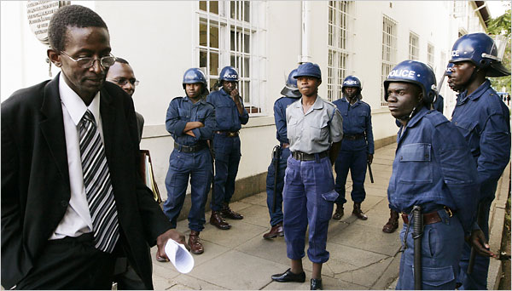
Tsvangirayi Mukwazhi/Associated Press
George Chikumbirike, a lawyer for Zimbabwe's Electoral Commission, left the High Court in Harare on Monday after he won the government's case.
JOHANNESBURG — The High Court of Zimbabwe on Monday dismissed an opposition demand for the immediate release of the results of a presidential election held 16 days before. Independent monitors say that the country’s autocratic president, Robert Mugabe, trailed badly in the vote and that he may have lost outright.
The opposition Movement for Democratic Change, contending that Mr. Mugabe and the military are illegally clinging to power, has called for people across the country to protest by staying home from work on Tuesday.
“We are working with a regime that has perfected the art of interfering with the judiciary,” said an opposition spokesman, Nelson Chamisa. “The court has chosen to be a pillar in a collapsing regime.”
Zimbabwean election officials said in a state-run newspaper that on Saturday they plan to start a recount of the presidential and parliamentary votes in 23 districts. A ruling on an opposition challenge of a recount is expected Tuesday in the same court system that rejected the opposition’s case on Monday.
Election monitors say the late recount is illegal and vulnerable to fraud because the integrity of the ballot boxes has not been safeguarded.
Election authorities had earlier announced that the opposition party won the most seats in Parliament, costing ZANU-PF, the governing party, control of the lower house of Parliament for the first time since the country’s independence in 1980. But a recount that switches the results in many of those seats would allow it to reclaim its majority.
Western diplomats, speaking on the condition of anonymity under usual diplomatic practice, said they were increasingly pessimistic that Mr. Mugabe would give up power willingly. They said it appeared that he and his party were manipulating the electoral system to drag out the process, restore public fear and deprive the opposition of its political momentum.
They predicted that if Mr. Mugabe stayed in office, as many as a million more Zimbabweans would join the millions who have already left the country. About 80 percent of the people are unemployed, and hyperinflation has rendered people’s earnings increasingly worthless.
Zimbabwean trade union and citizen group leaders, appearing at a forum in Pretoria on Monday, accused ZANU-PF and Mr. Mugabe, in power for 28 years, of trying to steal the election from the opposition leader, Morgan Tsvangirai.
“Zimbabwe is a political emergency,” said Gordon Moyo of the Bulawayo Agenda, a group that promotes open political debate in Zimbabwe.
Like the opposition, the groups say evidence is proliferating that the government is seeking to intimidate its opponents and carry out what amounts to a coup.
Political rallies have been banned. Foreign journalists have been arrested and detained. Mr. Tsvangirai’s lawyer, Innocent Chagonda, has been arrested.
Eleven election officials have been arrested on vote-tampering charges, which their lawyers say are baseless. Community leaders say the arrests are meant to scare the teachers and other civil servants who run polling places to allow vote-rigging if there is a presidential runoff.
Opposition supporters in remote rural areas have been beaten by youth militias and veterans of Zimbabwe’s liberation struggle, according to citizen groups and the opposition. Mr. Chamisa, the opposition spokesman, said a state-sponsored vigilante group stabbed an opposition election worker to death on Saturday Hurungwe, a village in the north.
“The rule of law is under attack through the use of violence,” said Irene Petras, executive director of Zimbabwe Lawyers for Human Rights.
Some analysts say the opposition’s options are narrowing. The recount ruling means that the courts, believed by many Zimbabweans to be politically compromised, are unlikely to be an effective avenue of appeal.
Opposition officials said they were buoyed by the statements of regional leaders over the weekend in support of their demands for monitoring by the opposition and for an atmosphere free of violence for any runoff in the presidential race.
But by Monday, more than 40 Zimbabwean civic and trade union groups had signed a letter demanding more forceful action from Zimbabwe’s neighbors to compel the government to announce the results, to prevent tampering with the vote and to ensure that there are international observers for any runoff.
Many Zimbabwean and South African human rights and trade union groups were outraged after President Thabo Mbeki of South Africa flew to Harare, the Zimbabwean capital, on Saturday to meet with Mr. Mugabe and declared that there was no crisis in the country. Mr. Mbeki has long insisted that he can best influence Zimbabwe through quiet diplomacy.
But Elinor Sisulu, a South African with the Crisis in Zimbabwe Coalition in Johannesburg, said the current situation is evidence that quiet diplomacy has failed. To say there is no crisis is wrong, she said. “It’s careless and insensitive of President Mbeki to make that statement,” she said. “It enables impunity from the regime.”
Celia W. Dugger reported from Johannesburg, and Graham Bowley from New York.
Copyright 2008 The New York Times Company

